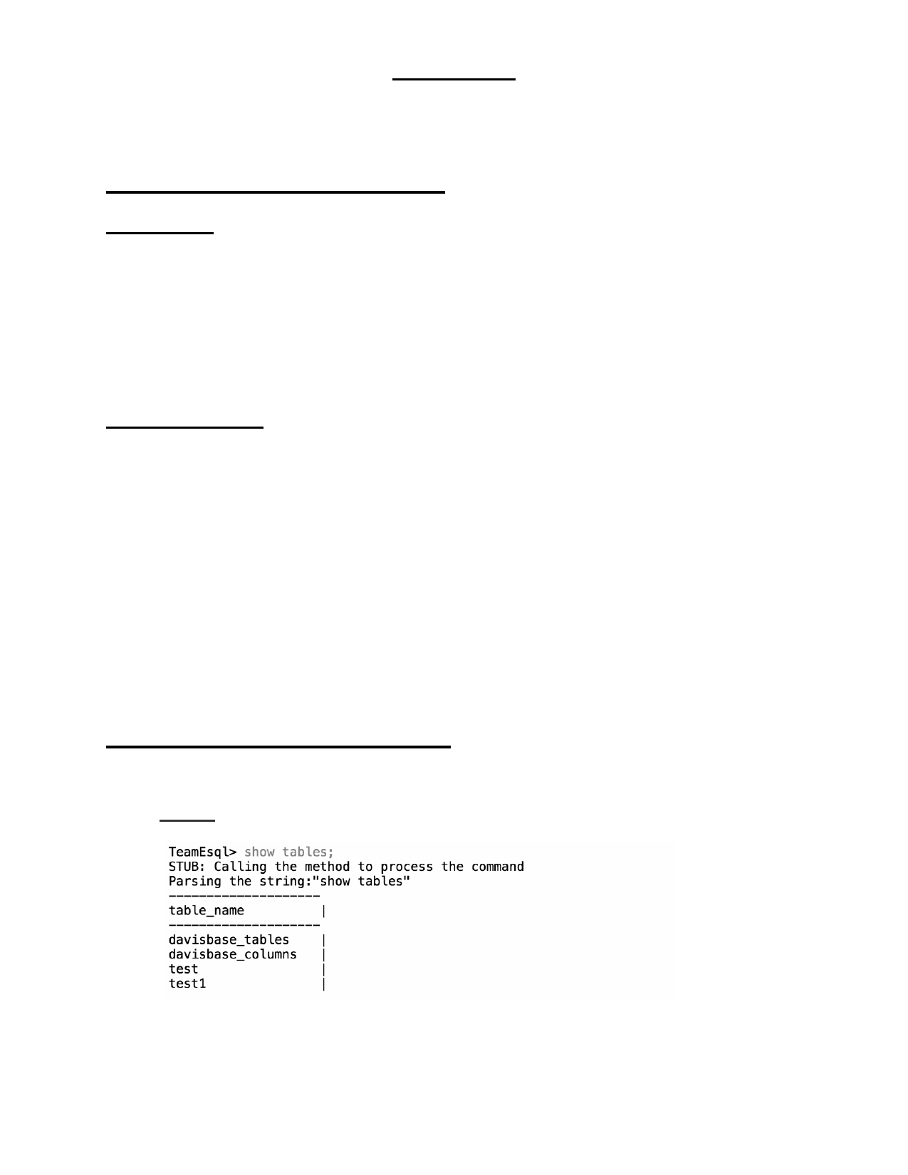**PROJECT**

The Project was developed using Eclipse IDE for Java.

**Instructions for running the application:**

From eclipse:

1) Extract the compressed folder downloaded from eLearning. 2) Import the folder TeamEDavisBase into the Eclipse IDE.

3) Run the DavisBase.java to start the application.

(or)

From local terminal:

4) Extract the compressed folder {Minal_Project}

5) Open terminal or command prompt

6) Navigate to the path where the folder has been extracted.

7) Change directory to the {Minal_Project}\ in terminal and compile all files using

the below command:

**javac *.java**

8) Run DavisBase.class file using the below command:

**Java DavisBase**

**The following commands are supported:**

**(a) Displays a list of all tables in DavisBase**

Syntax: SHOW TABLES;

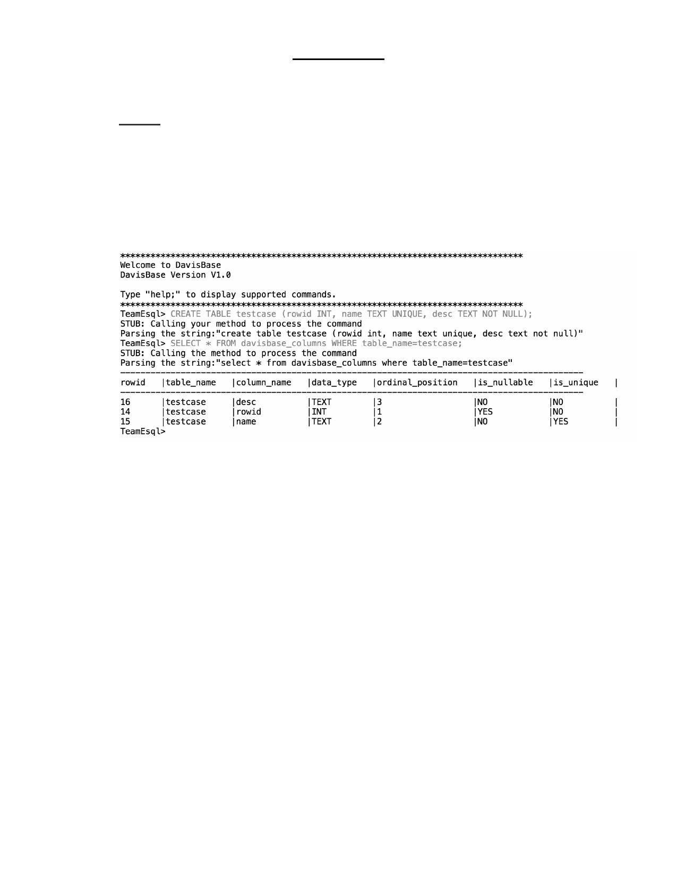**REPORT**

**(b) Create a new table**

Syntax: CREATE TABLE <table_name> (<column name> <constraint>, ..) ;

•

•

•

The first column is primary key, so it has to be of data type Integer.

There is an inbuilt AUTO INCREMENT function implemented for the

primary key which will increment maximum key when no value is passed.

The columns followed by primary key can be defined with constraints

UNIQUE/NOT NULL. The constraint will be stored in davisbase_columns against the respective parameter as shown below.

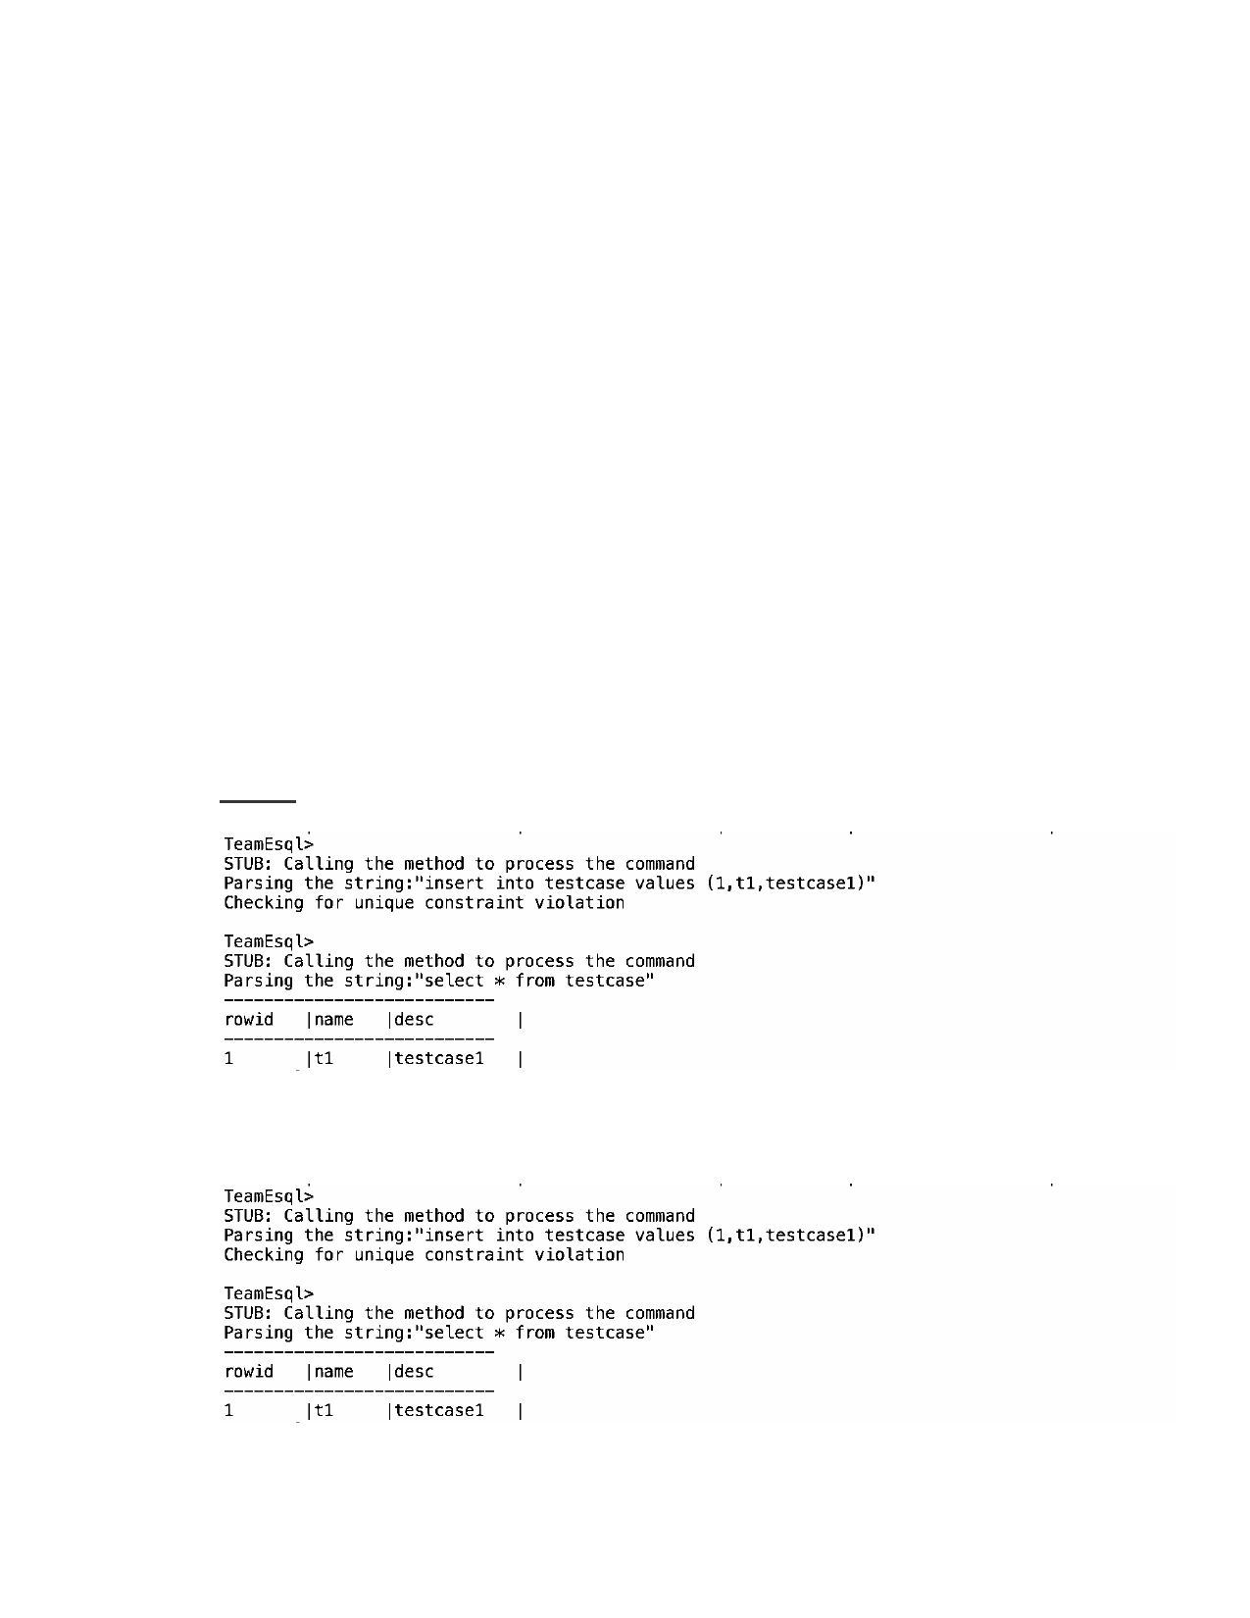

**(d) Insert record into table**

Syntax: INSERT INTO table_name <column_list> VALUES <value_list>;

With the auto increment feature on primary, the value for the column can be skipped for it to be generated dynamic.

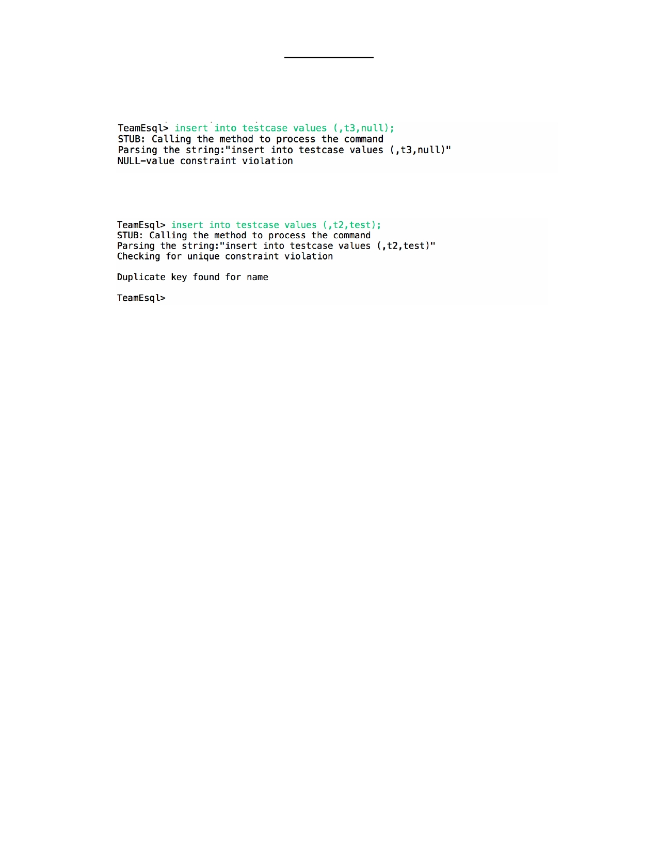**PROJECT**

When null is inserted into any not null column, then the database engine throws error.

When duplicate value is passed for column with unique constraint, then the database engine throws error.

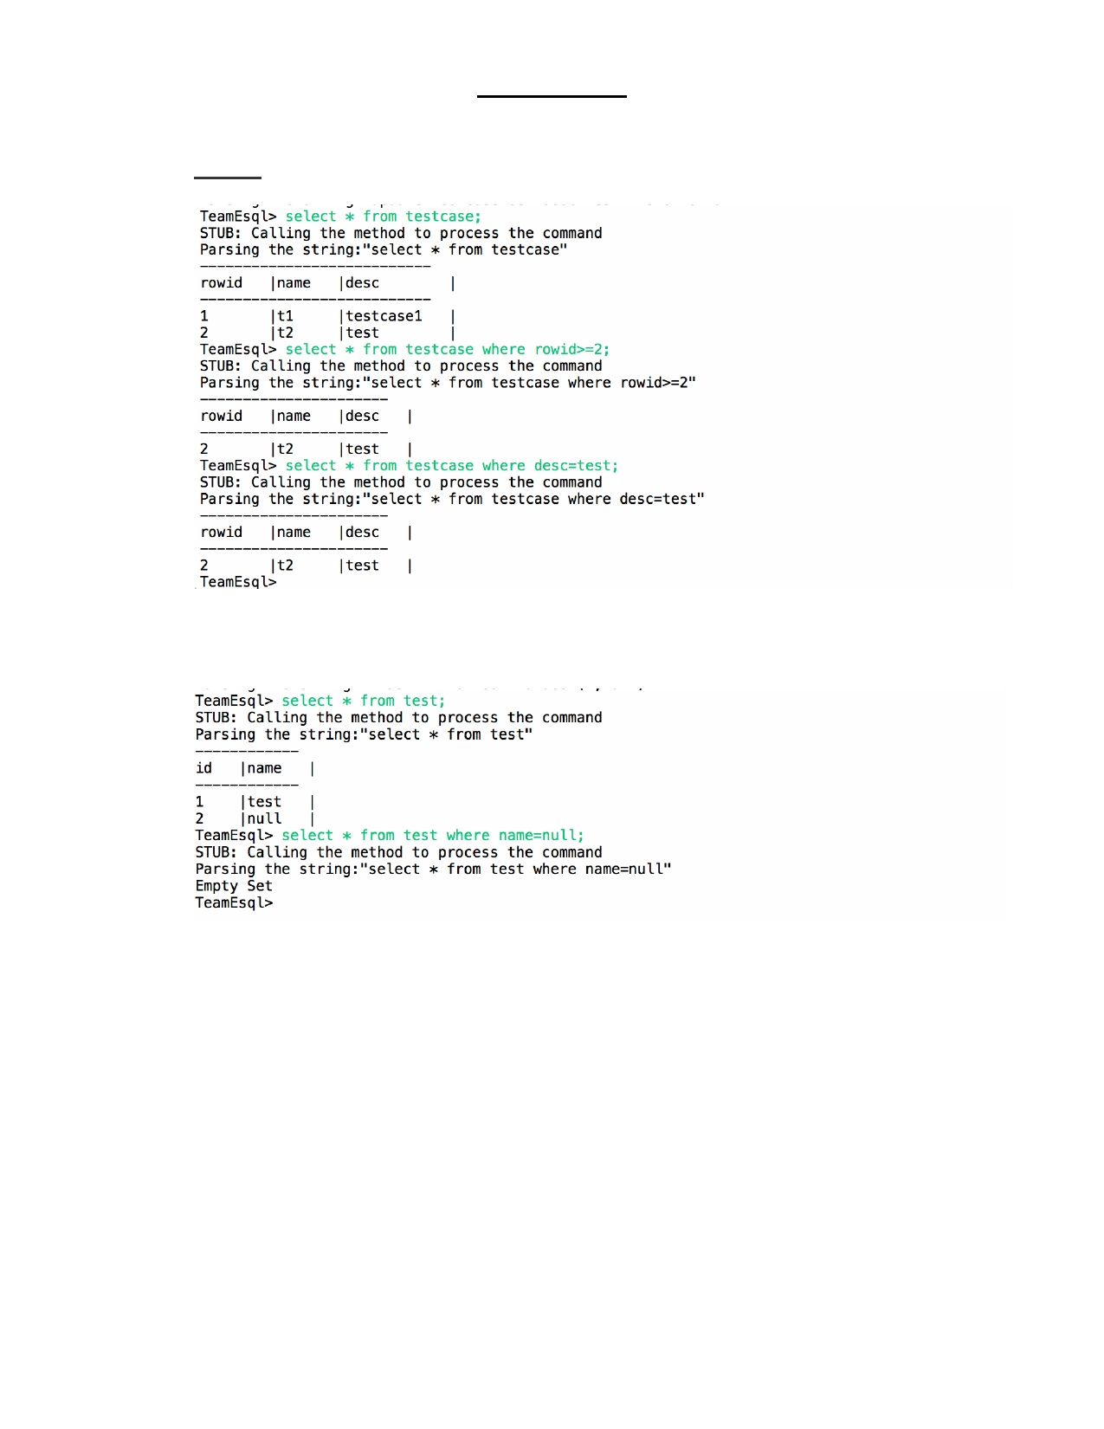**PROJECT**

**(g) Display records from a table**

Syntax: SELECT * FROM <table_name> [WHERE <condition>];

When NULL is used in where condition, the database engine equate null value in data with the where condition.

**PROJECT**

**(i) To get help on the command and syntax**

Syntax: help;

**(j) Exit from the database**

Syntax: exit;